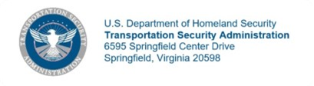

Acceptance Letter

[Date]

[Donor]
[Donor’s address]

Re: Letter of Acceptance from [Donor], of Donated Transportation Security Equipment (TSE) and Services at [location/ airport] [terminal/ checkpoint].

Dear [Donor Senior POC]:

On behalf of the Transportation Security Administration (TSA), I am pleased to accept the unconditional offer of the Donated Transportation Security Equipment and Services described in Attachment A to your letter of [date of attachment A], which [Donor], describes as having a fair market value of approximately $[value].

I hereby accept this donation under the provisions of 49 U.S.C. §§ 114(m) and 106(m). TSA acknowledges that this donation is not intended to mitigate or offset any TSA or other U.S. Government agency civil penalties, compliance proceedings, or other actions now pending or that may be initiated in the future, or to be considered favorably by TSA or any other U.S. Government agency in the Government’s handling of any contract, subcontract, or grant determinations
Please accept my sincere appreciation for this most generous and thoughtful donation.
Sincerely,

Holly C. Mehringer
Assistant Administrator
Chief Financial Officer
Chief Finance Office

